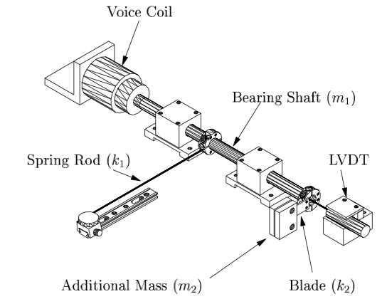

The bearing shaft (along with all attachments) form a lumped mass (*m*1). The slender spring rod behaves as a massless spring with spring constant *k*1. The voice coil actuator serves as a damper with damping constant *b*1, as well as providing the driving force. An additional mass *m*2 is attached to the bearing shaft by a thin aluminum blade (note in the diagram it is attached horizontally, while in the demo below, it is attached vertically). The aluminum blade can be reasonably modeled as a massless spring with light damping with spring constant *k*2 and damping constant *b*2. The LVDT (linear variable displacement transformer) is the mechanism that measures the position of the *m*1. All together, this is a fourth order system— a coupled spring mass system, which can be modeled as below. (This model should seem very familiar.)

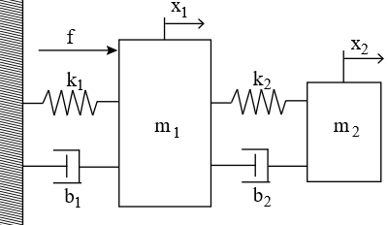

**L2.3. Simple RLC Circuits.**

Bookmark this page

A very simple passive AM radio receiver may be modeled by the following circuit.

The power source at left is the antenna, being driven by radio waves. The resistor at top is a speaker. The other components are a capacitor, at bottom, and an inductance coil, at right.

We will model this circuit using the same five-step process we used for mechanical systems in Lecture 1.

1. **Draw a diagram of the system.** We've already done Step 1!
2. **Identify and give symbols for the parameters of the system.** The diagram shows symbols for four standard electronic components. The first step in understanding the diagram is to define an orientation; say that current flows clockwise. Since it's a series circuit, the current through any of the wires is the same; write *I*(*t*) for it. Then we can say that the power source, at left, produces a voltage **increase** of *V*(*t*) volts at time *t* . This voltage increase may vary with time, and may be negative as well as positive. In fact we'll be especially interested in the case in which it is sinusoidal!

The meaning of each of the other components is specified by how the voltage **decrease** across it is related to the current flowing through it. For us, these relationships **define** the components. The impact of each component is determined by the constant appearing in these relationships.

|  |  |  |
| --- | --- | --- |
| Voltage drop across inductor: | *VL*(*t*)=*LI*˙(*t*) . |  |
| Voltage drop across resistor: | *VR*(*t*)=*RI*(*t*) . |  |
| Voltage drop across capacitor: | *CV*˙*C*(*t*)=*I*(*t*) . |  |

These components are connected in series, and so their voltage drops are related by Kirchhoff's voltage law: The voltage gain across the power source must equal the sum of the voltage drops across the other components:

|  |  |
| --- | --- |
| *V*=*VL*+*VR*+*VC*. |  |

1. **Declare the input signal and the system response.** The system is being driven by a signal coming in via antenna. This signal causes a voltage difference across the antenna, and it is reasonable to declare this voltage increase *V*(*t*) as the input signal. For system response, we are interested in the loudness of the speaker, which is proportional to the voltage drop across the resistor. So we declare *VR* to be the system response.

This means that we want to set up a differential equation relating *V*(*t*) to *VR*(*t*) .

1. **Write down a differential equation relating the input signal and the system response, using Newton's “***F*=*ma* **" in the mechanical case or Kirchhoff's laws in the electrical case.** Because *V*˙*C* appears in the definition of a capacitor, it is natural to differentiate Kirchhoff's voltage law, and rewrite in terms of *I* ;

|  |  |
| --- | --- |
| *V*˙=*V*˙*L*+*V*˙*R*+*V*˙*C*=*LI*¨+*RI*˙+(1/*C*)*I*. |  |

1. To make this into an equation relating the input signal *V* to the system response *VR* , we just have to remember that *VR*=*RI* . So multiply through by *R* and make this substitution, along with its consequences *V*˙*R*=*RI*˙ and *V*¨*R*=*RI*¨ :

|  |  |
| --- | --- |
| *RV*˙=*LV*¨*R*+*RV*˙*R*+(1/*C*)*VR*. |  |

1. **Rewrite the equation in standard form.** Input and output are already separated; to put this in standard form we just swap sides:

|  |  |
| --- | --- |
| *LV*¨*R*+*RV*˙*R*+(1/*C*)*VR*=*RV*˙. |  |

We're done. But before we discuss consequences, recall the equation we discussed in Lecture 1 describing the spring/mass/dashpot system driven through the dashpot:

|  |  |
| --- | --- |
| *mx*¨+*bx*˙+*kx*=*by*˙. |  |

These two equations are formally identical in the way they relate input and system response. This reflects a rough parallel between mechanical and electrical systems, in which

|  |  |  |  |
| --- | --- | --- | --- |
| **Mechanical** | | **Electrical** | |
| displacement | *x*,*y* | voltage drop, gain | *VR*,*V* |
| mass | *m* | inductance | *L* |
| damping constant | *b* | resistance | *R* |
| spring constant | *k* | 1/capacitance | 1/*C* |

Rather than trying to develop this as a formal equivalence, though, we think it's best to focus on the fact that the **mathematics** is identical up to change of notation.

## L2.4. Frequency response.

Bookmark this page

### Circuits as filters.

Let's now study the model of the AM radio receiver from the previous page.

The environment is filled with radio waves, electromagnetic oscillations vibrating at different frequencies. For example,

* many cellphones are broadcast at 1900MHz,
* medium range AM radio in the US is broadcast at 540-1600kHz, and
* FM radio is broadcast at 30-300MHz.

The input signal to our system is a variable voltage increase across the antenna that is a superposition of the results of all these radio waves.

Each AM radio station broadcasts in a small “band" of frequencies centered at a nominal broadcast frequency. Tuning the radio should allow frequencies near this nominal frequency to pass through to the speaker while suppressing all other frequencies.

We want to design our radio receiver so that its system response to the frequency of the radio station we want to listen to is much larger than the response to other frequencies.

In terms of gain, we can say that we want the gain to be greatest for a specific input frequency – call it *ωr* . The range of frequencies that is allowed through with little diminution is called the “pass band" of the receiver. To ensure that we don't receive interference from unwanted stations, it is desirable to try to arrange that the pass band is narrow enough to effectively suppress the signals arising from other sources.

Plot of amplitude gain with respect to input frequency (kHz).  
The boxes indicate the transmission bands of several   
AM radio stations in the Boston area. If we want to tune   
to the station centered at 950kHz, we seek a frequency  
response profile that looks rather like the blue curve.

A mechanism or circuit designed to suppress all frequencies except those near a specified frequency is called a “filter." A radio receiver suppresses signals with both higher and lower frequencies, and thus it is called a “mid-pass filter," and the range of frequencies it allows through is called the “pass-band."

### LTI systems as filters

Recall that we modeled this AM radio receiver circuit by the differential equation

|  |  |
| --- | --- |
| *LV*¨*R*+*RV*˙*R*+(1/*C*)*VR*=*RV*˙ |  |

that is analogous to the associated mechanical system

|  |  |
| --- | --- |
| *mx*¨+*bx*˙+*kx*=*by*˙. |  |

In [Lecture 1](https://courses.edx.org/courses/course-v1:MITx+18.03Lx+3T2020/courseware/intro/lec1/3) you made some observations about the mechanical system using the [Mathlet](http://mathlets.org/mathlets/amplitude-and-phase-2nd-order-ii/) Amplitude and Phase 2nd Order II. You discovered through the mathlet that the maximum gain of this system (when *m*=1 ) for any fixed values of *k* and *b* , is *g*=1 ; and that this value occurs when *ω*=*ωr*=*k*/*m*−−−−√ , independent of *b* . If we think of this system as an AM radio receiver, the resonant peak is at the frequency we are tuning the radio to. The resonant value is given by

|  |  |
| --- | --- |
| *ωr*=1*LC*−−−√ |  |

and is independent of the resistance *R* . So this is important information: With inductance fixed, you tune the radio by changing the capacitance. The environment is filled with radio waves at a variety of frequencies. The AM receiver responds weakly to most and relatively strongly only to frequencies at or near the resonant frequency.

There's a general lesson here for LTI systems: it's important to be able to visualize the system response to a whole spectrum of different input frequencies. Since we are interested in the sinusoidal system response, we need to specify only two parameters relative to the input frequency to understand this response completely: the gain and the phase lag. These parameters depend upon the input frequency, but not on the input amplitude and not on the phase of the input relative to some standard signal.

The two main tools that we have for visualizing the gain and phase lag as functions of the frequency are the **Bode Plot** and the **Nyquist Plot** . There are two Bode plots, one for gain and one for phase. The horizontal axis for each plot is frequency, one plot shows how the gain depends on the frequency of the input signal, and the other shows how the phase depends on the frequency of the input signal. The next problems allow you to explore the Bode plots to understand the frequency response directly.

### Bode Plots

3 points possible (graded)

Each of the Amplitude and Phase [Mathlets](http://mathlets.org) allows visualization of plots of the gain and the phase lag as functions of frequency. To see these two graphs on the Mathlet below, check the box marked “Bode plots." ([Why “Bode"?](https://courses.edx.org/courses/course-v1:MITx+18.03Lx+3T2020/courseware/intro/lec2/10)) Take a minute now to understand how the Bode plots reflect the behavior of the system. Note that the lower graph plots the phase **gain** rather than the **lag**, that is, −*ϕ* rather than *ϕ* .

Here are some questions for you to guide your exploration of the Mathlet. Remember, you can change the system parameters *k* and *b* using the sliders below the graph. Vary them and confirm your hypothesis that *ωr*=*k*−−√ .

Why bode?

**1. Why “Bode"?** Bode plots are named after Hendrick Wade Bode, 1905–1982. Bode (rhymes with toady) was one of the fathers of modern control theory. For most of his career he worked at Bell Labs. During World War II he devised the feedback mechanism linking radar data to anti-aircraft fire. After the war he occupied high administrative positions at Bell Labs. In 1967 he retired as Vice President in charge of military development and systems engineering, and took up the position of Gordon McKay Professor at Harvard, a post he held till 1974.

Our use of the phrase “Bode plots" in this course is inaccurate in several respects. First of all, in engineering applications one typically has to cope with a wide range of frequencies. To represent them, one plots the log of the frequency horizontally. Similarly, the gain often spans a wide range of values, and to provide clear visualizations of the gain it is sensible to plot log*g*(*ω*) rather than *g*(*ω*). So typically the gain Bode plot uses a log-log scale, as shown below.

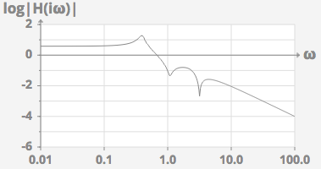  
Log-log scale Bode plot.  
(Note the vertical axis appears linear, but is plotting log(H(iω)).)

The vertical logarithmic scale is often measured in “decibels." The decibel measure of gain *g* is 20log10*g* Db. This can also be written 10log10*g*2, which is of interest since the power of a sinusoidal signal is proportional to the square of its amplitude. Use of these units originated at Bell Labs in the 1920's.

The phase Bode plot uses log*ω* horizontally, and −*ϕ* vertically. No need for a log vertically; after all, in a sense *ϕ* is already a logarithm – in the complex gain it occurs as *e*−*iϕ*.

Even these smooth log-log plots are not quite the thing that Bode introduced. He provided quick and efficient ways to sketch these plots, or piecewise linear approximations of them.

Poles of the transfer functions:

The transfer function formalism makes our notation neater, and broadens its scope: *s* rather than *iω* , and it gives information about more general system responses. But this generalization of *G*(*ω*) is extremely useful in understanding the complex gain itself, as well.

The transfer function is a fairly complicated gadget. You can't really graph it! It takes a complex number as input, so its graph lies over the complex plane; and it produces a complex number as output, which needs another two dimensions to represent. So we can't graph it in three dimensions.

But the most useful part of the complex gain is its magnitude – the gain. So instead of graphing *H*(*s*) , we will graph |*H*(*s*)| . This is now a surface lying over the complex plane. Let's do some examples.

For a start, suppose our system is an undamped spring system, driven through the spring. This system is modeled by the equation

|  |  |
| --- | --- |
| *mx*¨+*kx*=*ky* |  |

This is the harmonic oscillator with natural frequency

|  |  |
| --- | --- |
| *ωn*=*k*/*m*−−−−√ |  |

It's expressed in standard form *P*(*D*)*x*=*Q*(*D*)*y* , with

|  |  |
| --- | --- |
| *P*(*s*)=*ms*2+*k*,*Q*(*s*)=*k*. |  |

So, its transfer function is

|  |  |
| --- | --- |
| *H*(*s*)=*kms*2+*k*=*k*/*ms*2+*k*/*m*=*ω*2*ns*2+*ω*2*n*. |  |

Let's think first of the graph of

|  |  |
| --- | --- |
| *g*(*ω*)=|*G*(*ω*)|=|*H*(*iω*)|=*ω*2*n*|(*iω*)2+*ω*2*n*|=*ω*2*n*|*ω*2*n*−*ω*2|. |  |

When *ω*=±*ωn* , the denominator vanishes and *G*(*ω*) isn't defined. This is resonance! When *ω* is near to ±*ωn* but not quite equal to it, the value of the gain is large; the sinusoidal system response has amplitude much larger than the amplitude of the input signal. As |*ω*| gets large, the gain falls off to zero. The graph looks like this:

The resonance occurs at input frequency *ωn* .

This is the amplitude response curve of the system. Note that the frequency enters here only through its square. We lose nothing, and gain quite a bit, by formally allowing *ω* to take on negative values as well as positive ones.

Now let's think about the absolute value of the full transfer function,

|  |  |
| --- | --- |
| |*H*(*s*)|=*ω*2*n*|*s*2+*ω*2*n*| |  |

The polynomial *s*2+*ω*2*n* has two roots, *s*=±*iωn* . At these values of *s* , the transfer function is not defined. When *s* is near to ±*iωn* , the value of |*H*(*s*)| is large; when |*s*| gets big, |*H*(*s*)| falls off to small values. The graph looks like this:

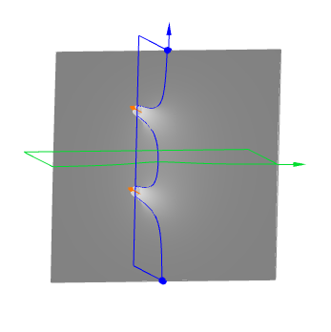  
Graph of |*H*(*s*)| with purely imaginary poles  
The blue curve lies over the imaginary axis. The blue curve on the surface is precisely the amplitude response curve.  
We have also outlined a box in the plane above the imaginary axis for emphasis. The green curve lies over the real axis.  
It represents the gain of the system if it is fed a **real** exponential input.

If you slice the graph of *H*(*s*) with a plane above the imaginary axis, you get the graph of the gain, which is the amplitude response curve – the graph of *g*(*ω*)=|*H*(*iω*)| .

I think of this graph as like a tent. The canvas is draped over two tall poles, one at *iωn* , the other at −*iωn* . Do you agree?

The points ±*iωn* are called **poles**, perhaps because they lie at the base of the tent-poles. The most important features of the graph of |*H*(*s*)| – and so of the gain curve – are captured by the location of the poles. A diagram of the complex plane with the location of the poles marked by **X** 's is called a **pole diagram** of *H*(*s*) .

In our cases the poles of *H*(*s*) are exactly the roots of the denominator, *P*(*s*) (assuming *P*(*s*) and *Q*(*s*) have no common factors).

Now, what happens if we introduce some damping? Let's set *m*=1 to save on symbols. So

|  |  |
| --- | --- |
| *x*¨+*bx*˙+*kx*=*ky*, |  |

|  |  |
| --- | --- |
| *P*(*s*)=*s*2+*bs*+*k*,*Q*(*s*)=*k*, |  |

and

|  |  |
| --- | --- |
| *H*(*s*)=*Q*(*s*)*P*(*s*)=*ks*2+*bs*+*k*. |  |

The roots of *P*(*s*) can be found by the quadratic formula, or, if you prefer, by completing the square:

|  |  |
| --- | --- |
| *s*2+*bs*+*k*=(*s*+(*b*/2))2+(*k*−(*b*2/4)), |  |

so *s* is a root if (*s*+(*b*/2))2=−(*k*−(*b*2/4)) . With *b* small (smaller than 2*k*−−√) , the system is underdamped; the right hand side is negative; and the roots are

|  |  |
| --- | --- |
| *r*=−(*b*/2)±*iωd*, |  |

where

|  |  |
| --- | --- |
| *ωd*=*k*−(*b*2/4)−−−−−−−−√ |  |

is the **damped angular frequency**. The roots have also acquired a real part that is negative. The damping has pushed them off the imaginary axis!

Because of damping there is no pure resonance. Engineers call the frequency that produces the largest gain (at least if *b* is small relative to *k* ) “practical resonance". The amplitude response curve is:

The transfer function is now

|  |  |
| --- | --- |
| *H*(*s*)=*ks*2+*bs*+*k*. |  |

This function has poles at the roots of the denominator, that is, at −(*b*/2)±*iωd* . The pole diagram is this:

The graph of |*H*(*s*)| exhibits two infinitely high peaks over these two points.

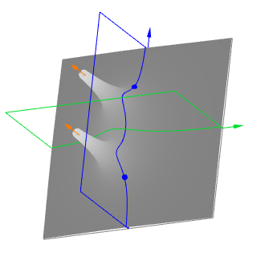  
Graph of |*H*(*s*)| , poles no longer along imaginary axis

These points are no longer on the imaginary axis, but, if *b* is small relative to *k* , they are not far off. So if you walk this terrain on a path over the imaginary axis, starting from *iω* for *ω* larger than the resonant frequency, you will climb up the shoulder of the mountain near −(*b*/2)+*iωd* ; then descend to a valley that reaches a relative minimum at *ω*=0 ; and then goes through a symmetrical elevation gain and loss for negative *ω* .

This hiking imagery is very useful. It explains how poles influence the gain curve.

Play with the mathlet below which plots |*H*(*s*)| to get a better understanding of what is happening. (By clicking on and dragging the large graph on the left, you can change the orientation of the graph of |*H*(*s*)| . Click the top or side button to reset the orientation.)

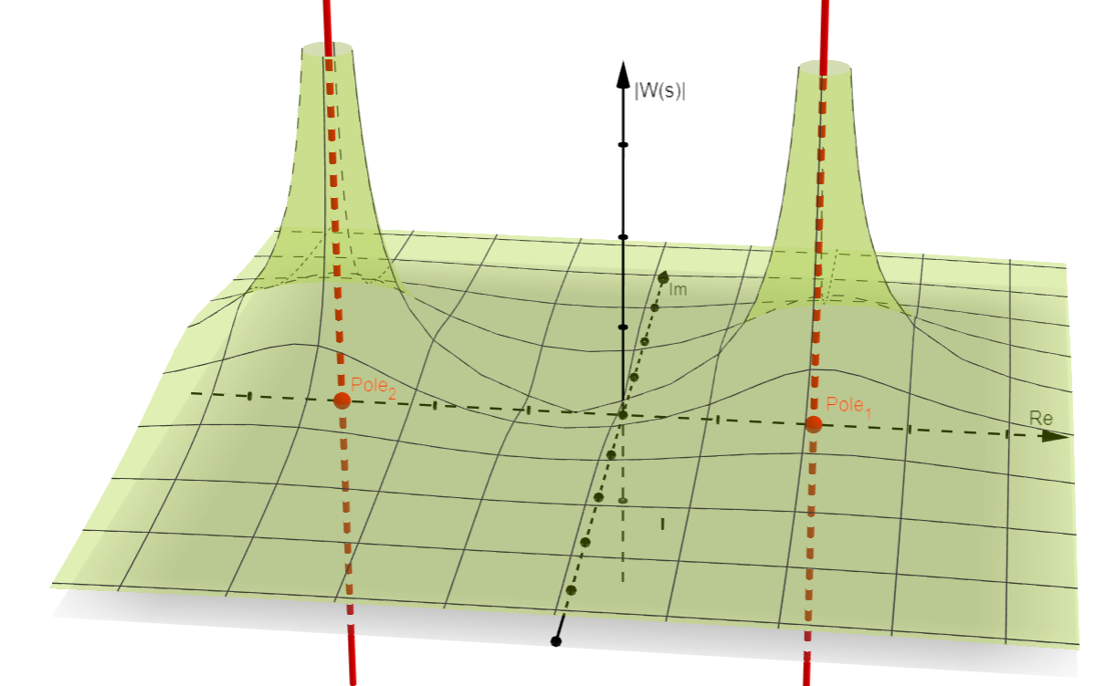

For w(s)=1/(s-2) + 2/(s+3)